

Ben Baxter | t00032663 | January 26, 2015

Comp 2230 Assignment 2

A Study in Awesome

Problem Definition:

Describe problem

1. Complete LinkedQueue’s methods
2. Complete CircularArrayQueue’s methods
3. Create a Palindrome Tester

Input

1. Test inputs to make sure each method worked properly(three strings of basic characters)
2. Test inputs to make sure each method worked properly(three strings of basic characters)
3. A Palindrome String and non-palindrome string

Output

1. First call, isEmpty both true and false and size counts of 2 and 0 with toString output
2. First call, isEmpty both true and false and size counts of 2 and 0 with toString output
3. Both True and False depending on the input.

Analysis of the problem:

List subtasks

* Create all methods in LinkedQueue and CircualrArrayQueue
* Create Palindrome Tester
* Create main test script for checking all methods viability

List prototypes with pre and post conditions

* ?

Analysis and algorithm for each subtasks

* Big O not require for this assignment

Test cases:

Are they listed?

* Test Cases are contained in the main java doc

Complete test cases

* See Runtime Output after the code.

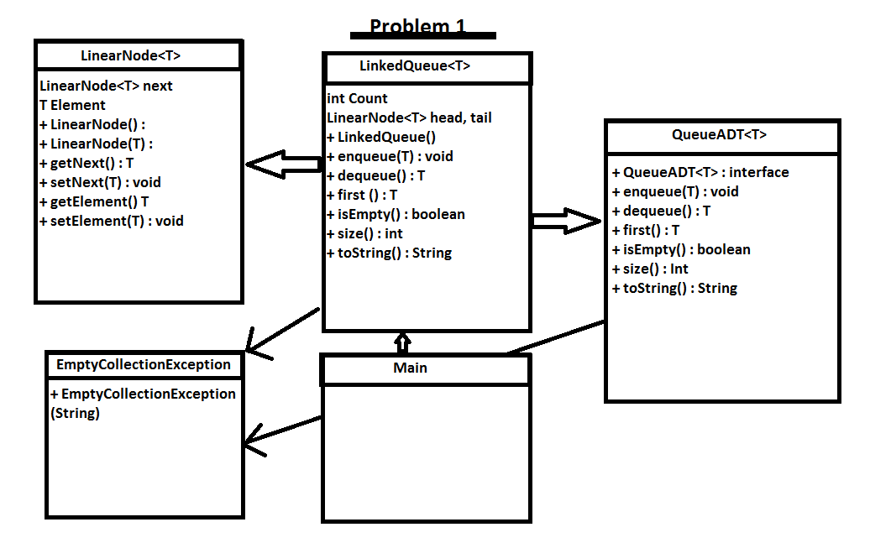

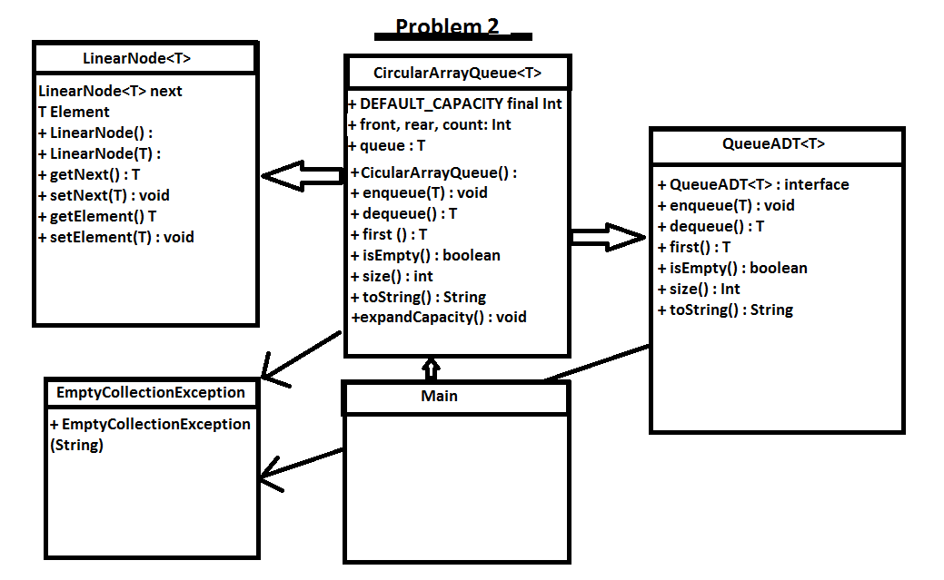

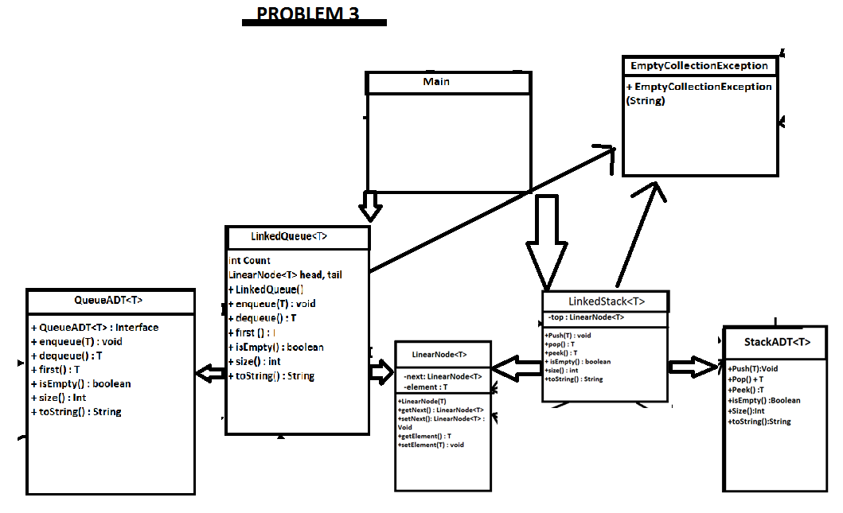

Runtime Output

isEmpty(1): true

Enqueue L1: ABCDEEDCBAABCBA

isEmpty(2): false

Size = 2

toString: ABCDEEDCBA

First: ABCDE

Dequeuing L1

isEmpty(3): true

Size = 0

toString:

2isEmpty(1): true

2Enqueue L2: ABCDEEDCBAABCBA

2isEmpty(2): false

2Size = 2

2toString: EDCBAABCDE

2First: EDCBA

Dequeuing L1

isEmpty(3): true

Size = 0

toString:

abba

Is a palindrone?: true

Process finished with exit code 0

isEmpty(1): true

Enqueue L1: ABCDEEDCBAABCBA

isEmpty(2): false

Size = 2

toString: ABCDEEDCBA

First: ABCDE

Dequeuing L1

isEmpty(3): true

Size = 0

toString:

2isEmpty(1): true

2Enqueue L2: ABCDEEDCBAABCBA

2isEmpty(2): false

2Size = 2

2toString: EDCBAABCDE

2First: EDCBA

asdf

Is a palindrone?: false

Process finished with exit code 0